Networking Training
Allen Paul - Assignment
Module 3 and 4 :

Problem 1:
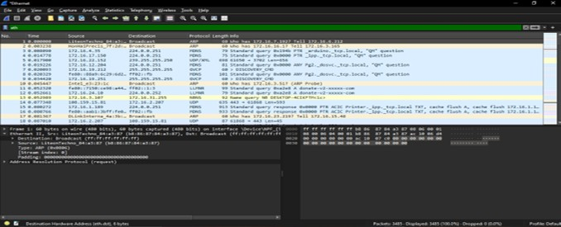

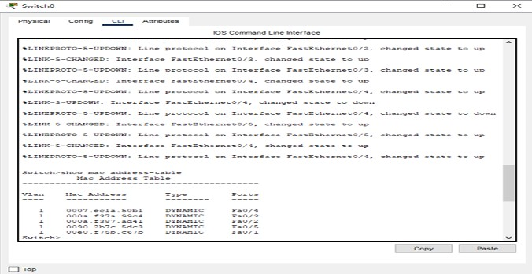

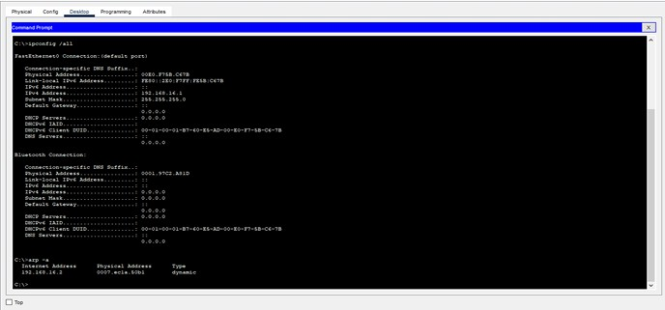

Problem 2:
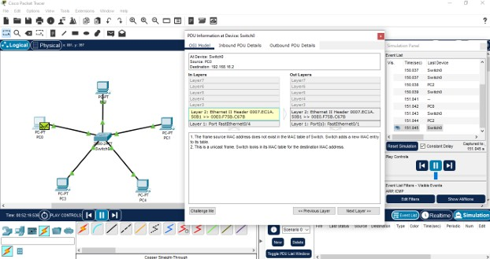

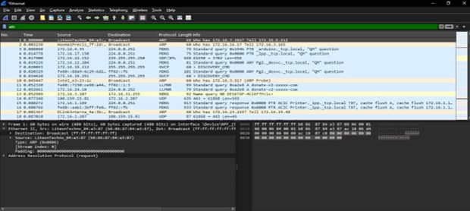

Problem 3:
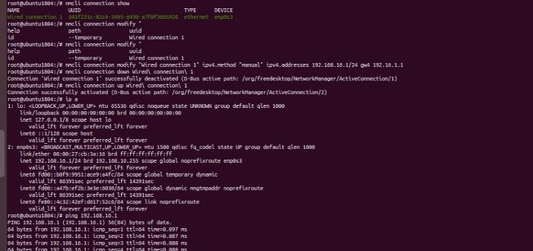
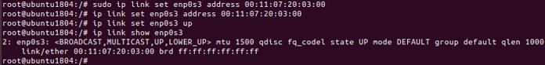

Problem 4 :
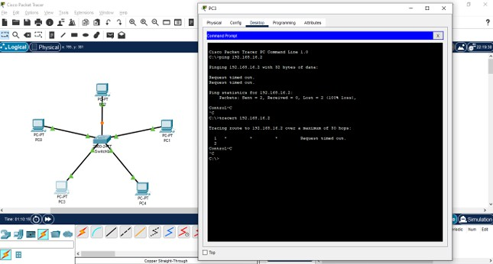
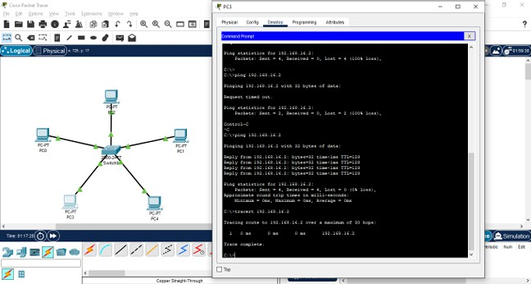

Problem 5,6,7:
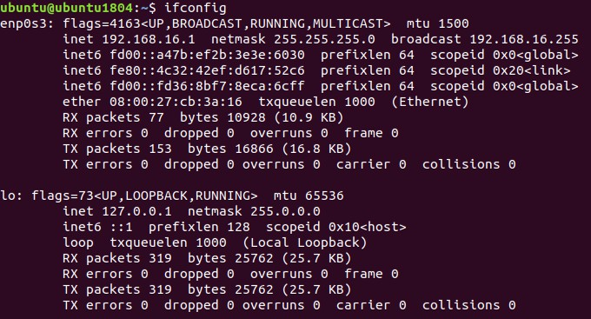
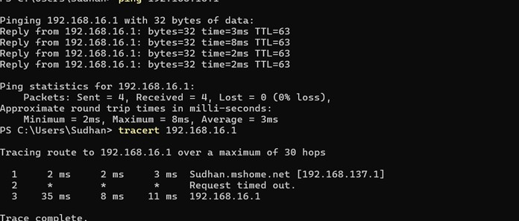

Problem 8:

The Linux kernel provides strong support for Ethernet communication, ensuring transmission and reception through its network stack.
Ethernet devices are represented as network interfaces (eth0, ens3) and managed by the netdev subsystem, accessible under /sys/class/net. Kernel modules drivers interact with physical NICs to facilitate network communication.
When sending data, the socket API passes application data to the TCP/IP stack, which encapsulates it and hands it over to the NIC driver for transmission.
Upon receiving data, the NIC generates an interrupt, prompting the kernel to process the Ethernet frame and forward it to the appropriate protocol handler or application.
The Linux kernel dynamically loads Ethernet drivers such as e1000 for Intel NICs and r8169 for Realtek NICs to handle packet transmission, reception, and network interface functions.
Users can inspect NIC configurations and driver details using ethtool and sysfs. Network traffic is managed by directing packets through routing tables.

Problem 9:

Find the network interface in which LAN devices are connected Cmd: ip link show
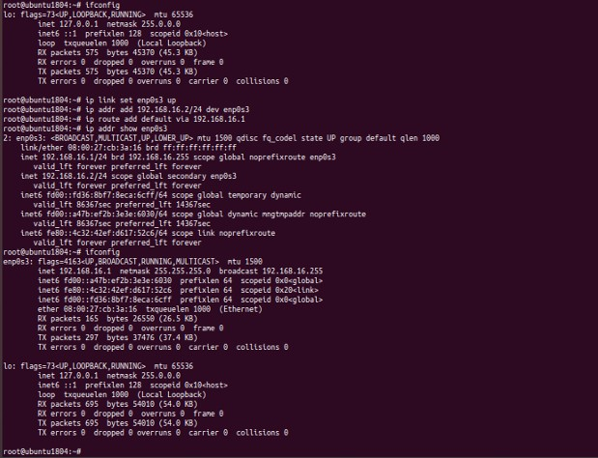
Enable the network interface (up) Cmd: ip link set enp0s3 up Assign static IP Cmd: ip addr add 192.168.16.1/24 dev enp0s3 Set default gateway Cmd: ip route add default via 192.168.1.1

Problem 10:

Use bridge link to list active bridges.
Run bridge fdb show to display learned MAC addresses and their associated interfaces. Use ip link show to view available network interfaces and their MAC addresses.
Send a ping request between two devices using ping 192.168.1.2.
After generating traffic, re-run bridge fdb show to check if the switch has learned the device’s MAC address.
These commands help in troubleshooting Software-Defined Networking (SDN) connectivity.
